**DEM model for NPH simulation**

**Geometry**

I have started using a simplified geometry for the brain.

I have generated a sphere (10 cm radius) and an .stl file using Gmsh.

I converted the .stl file into a .gts file and then imported into my code as a predicate.

I believe it is possible to create a more realistic model (for example 2 concentric sphere, where the inner one represents the ventricles) or even import a patient specific mesh.

In a previous email, you mentioned the fact that:

“ we need to define a row or two of spheres which align with the outside boundary circular wall in a very regular way like a chain, and then have separate "fluid channel" between two rows of particles”. I still did not figure it out how to do it. I can make more research and talk to Robert about it.

**Packing**

The predicate has been filled with spheres using the *regularHexa* function that return set of spheres in regular hexagonal grid,.

The spheres have a radius of 0.50 cm and there is no gap between the spheres.

These values can be easily adjusted.

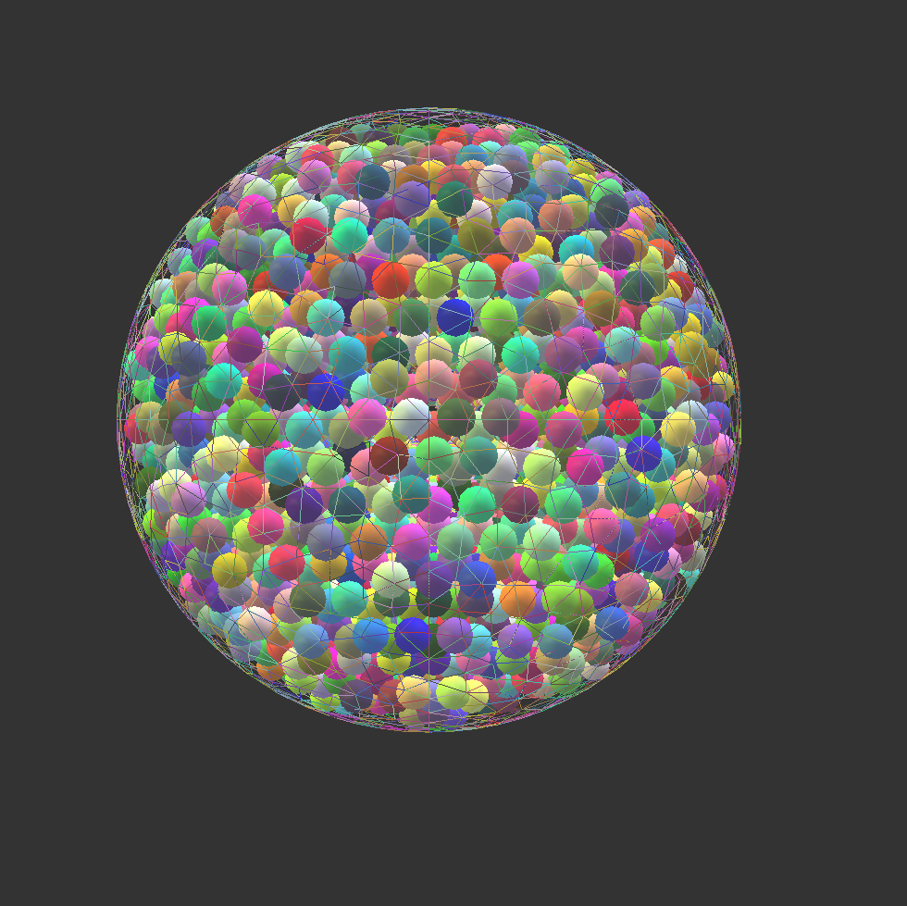  
Illustration 1: Snapshot of the model

**Material properties**

Unfortunately, there is not much agreement on the material properties of brain tissue. According to Li Et Al Influences of brain tissue poroelastic constants on intracranial pressure (ICP) during constant-rate infusion the Young modulus is around 10000 Pa. According to Tully and Ventikos Cerebral water transport using multiple-networkporoelastic theory: application to normalpressure hydrocephalus instead the Young modulus is closer to 500Pa.

As concerns the Poisson ratio this varies between 0.35 and 0.48.

I have defined the material properties as:

idTissue=O.materials.append(FrictMat(young=500.0,poisson=.35,frictionAngle=.6,label="concrete"))

I have to understand which is the best value for the friction angle.

**Simulation loop**

From Yade’s manual:

*In a typical DEM simulation, the following sequence is run repeatedly:*

*• reset forces on bodies from previous step*

*• approximate collision detection (pass 1)*

*• detect exact collisions of bodies, update interactions as necessary*

*• solve interactions, applying forces on bodies*

*• apply other external conditions (gravity, for instance).*

*• change position of bodies based on forces, by integrating motion equations.*

*Each of these actions is represented by an Engine, functional element of simulation. The sequence of engines is called simulation loop.*

We can use this setup. Eventually also a FlowEngine can be incorporated.

O.engines=[

ForceResetter(),

InsertionSortCollider([Bo1_Sphere_Aabb(),Bo1_Facet_Aabb()],label='collider'),

InteractionLoop(

[Ig2_Sphere_Sphere_ScGeom(),Ig2_Facet_Sphere_ScGeom()],

[Ip2_FrictMat_FrictMat_FrictPhys()],

[Law2_ScGeom_FrictPhys_CundallStrack()],

),

NewtonIntegrator(damping=0.1,gravity=[0,0,0]),

# FlowEngine(label="flow"), commented at the moment

]

**ForceResetter():** itresets forces at each timestep

**InsertionSortCollider():** it manages collision between particles and facets. The functors Bo1_Sphere_Aabb() and Bo1_Facet_Aabb() are bound functors and define the Axis-aligned bounding boxes (Aabb) for spheres and for facets. At this stage we only have spheres and facets so it should be enough.I do not see any parameters to be set here.

InteractionLoop(): in this loop the interaction between the spheres. It needs 3 functors: Ig2, Ip2, Law functors respectively.

The functor prefixed with Ig2 holds geometrical configuration of the two particles in collision; it is updated automatically

as the particles in question move and can be queried for various geometrical characteristics, such as penetration distance or shear strain.

**Fluid Engine**

It is possible to incorporate the fluid dynamics with the Flow engines.

It seems possible to impose the pressure in one point like this:

flow.imposePressure(Vector3((0.0,0.0,0.0)), 10.0)

Unfortunately, it seems difficult to impose boundary conditions. I have already asked a question to Yade forum and waiting for an answer

Bibliography

"LiEtAl2013": , Influences of brain tissue poroelastic constants on intracranial pressure (ICP) during constant-rate infusion,

"TullyVentikos2010": , Cerebral water transport using multiple-networkporoelastic theory: application to normalpressure hydrocephalus